Name: ______________________________________________
GeoGebra Lesson: Similar Triangles

- Click on the toggle arrow next to GRAPHICS and then the GRIDLINES icon.

- Click on the 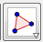 icon and select POLYGON.
  - Use the cursor that appears to plot the following points in order: (6,5), (7,7), (3,6), and (6,5) to complete the triangle.
- Click the 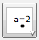icon to input a slider and click the point (9,10) to place the slider there.
  - Rename the slider “scale”.
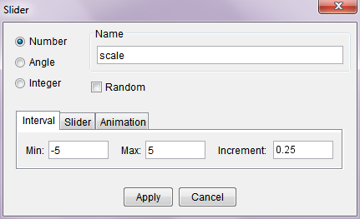
  - Change the interval from 0 to 5 and the increment to 0.25.

- Click the 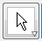 icon, then the triangle on the graph, then the 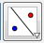icon. Choose DILATE FROM POINT.
  - Place the point at (3,11). A prompt will appear. Type in “scale” as the factor.
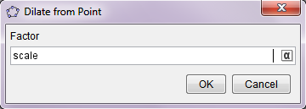

- Move the slider around. What happens? What does it mean to scale?
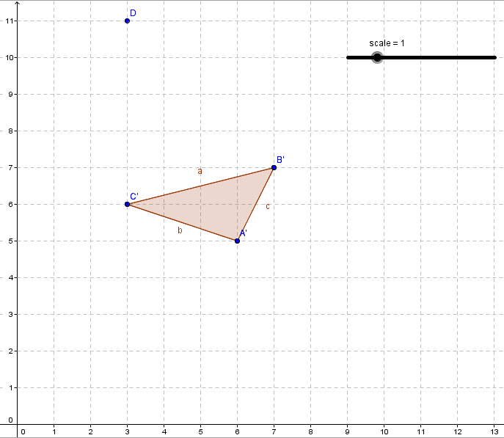
______________________________________________________________________________
______________________________________________________________________________

- Set the slider to 0.5. Find the measures of the corresponding sides of each triangle.
measure a = __________ measure a’ = __________
measure b = __________ measure b’ = __________
measure c = __________ measure c’ = __________

What do you notice about the relationship between corresponding sides?
______________________________________________________________________________
If two triangles are similar, then all three sets of corresponding sides are _________________________.
This is called the Side-Side-Side (SSS) Theorem for Similar Triangles.

- Click the 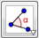 icon. Choose ANGLE.
  - Click point B, then point A, and then point C. m <A=_________
  - Click point B’, then point A’, and then point C’. m <A’=_________
    - m <A and m <A’ are __________________.
  - Click point A, then point C, and then point B. m <B=_________
  - Click point A’, then point C’, and then point B’. m <B’=_________
    - m <B and m <B’ are __________________.
If two triangles are similar, then two sets of corresponding angles are _________________.
This is called the Angle-Angle (AA) Theorem for Similar Triangles.

Examples:
- Use SSS to show the triangle with coordinates (-1,2), (-4,1), (1,-1) is similar to the triangle with coordinates (-3,-2), (-9,-4), (1,-8).
- Using the triangles from example 1, use AA to show they are similar.
- Find a similar triangle to a triangle with points (1,2), (3,4), and (4,1). Show it is similar using SSS and AA.
- Find two triangles which are similar by a scale of 1.5.

