Name ________________________________________ Date ____________________
How Fast Does Light Travel in Water?
Some Useful Formulas: $a^{2}+b^{2}=c^{2}$ Time = Distance ÷ Rate
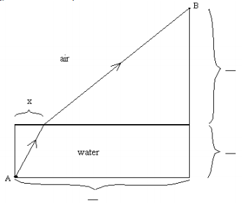
- Fill out the diagram below.

- Assume light travels 15 cm per nanoseconds. (This is just used as an initial guess.) Find the length of time in nanoseconds it would take light to travel from Point A to Point B following the path…
  - …when x=1 cm.
  - …when x=5 cm.
  - …when x=10 cm.
- For which value of x creates the best path?
- Write a function, T(x), for the time it takes light to travel from A to B. Use 30 cm/nanosecond as light’s speed in air and 15 cm/nanosecond as light’s speed in water. Substitute in variables from the diagram below. *Remember 15 cm/nanosecond is only a guess until we can figure out x.
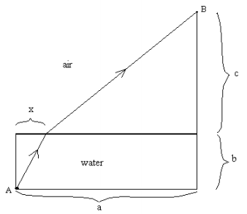
- Use your calculator to estimate the path light will take using the formula and measurements from number 4. (What is the x-value?)
  - Does light actually take the path you found? If not, why not?
- Now we can find the value of x. Put a ruler across the top of the container with zero lined up with the string. One person should hold a pencil point at th the surface of the water at the value you computed x to be in quester 5, and another person should be looking at the point from the point on the dowel. If the pencil doesn’t line up with the point, the observer should instruct their classmate to move the pencil until it does line up.
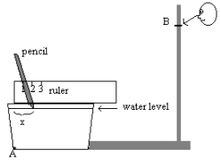

What measurement on the ruler does the pencil line up with? This is our x-value, or the distance from A at which light enters the water.
- We now have all the information we need to find the speed of light in water. Using the formula and keeping x as a variable, substitute different values for the speed of light until you get as close as possible to the actual x-value you measured. Once you get the actual x-value, you have found the speed of light under water.
  - The speed of light is…?
- How did you use math to approximate the speed of light in water?

Extension Activity:
- Using the same set-up as before, fill the container to a different depth than before. Use the result your class got for the speed of light in water to predict where you would see the object; that is predict the value of where the path of light emerges from the water. Then observe as before to see where it actually emerges. Comment on your result and explain it.

